**Output Screenshots**

* 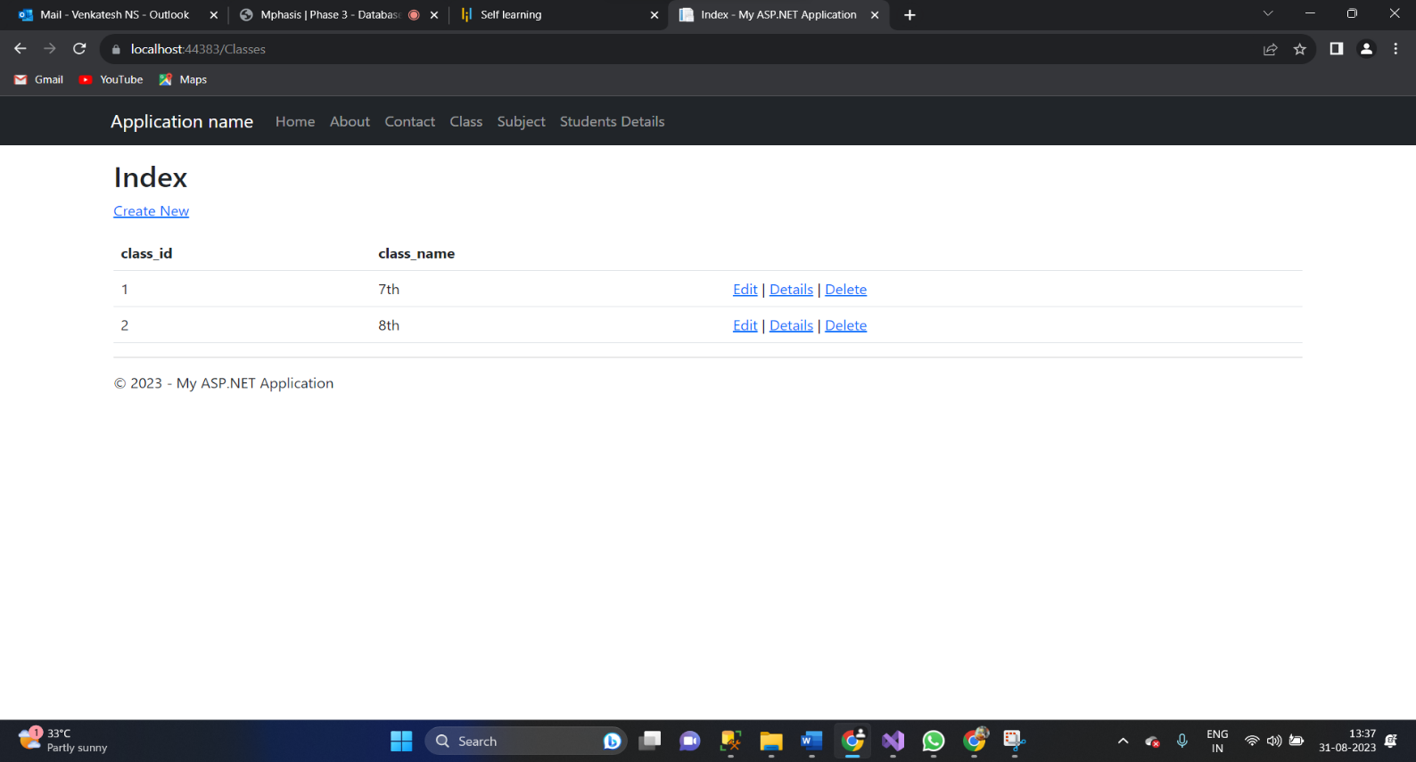**Classes output**
* **A screenshot of a computer

  Description automatically generatedSubject output**
* **A screenshot of a computer

  Description automatically generatedStudent output**